Formatting String Using the format() Function

Just like numbers, we can also use format() function to format strings. To format string we use type code s and along with a specified width, For example:

|  |  |
| --- | --- |
| 1  2  3  4 | >>>  **>>> print**(format("Python", "10s"))  Python  >>> |

[Try it now](https://overiq.com/python-online-compiler/qj2/)

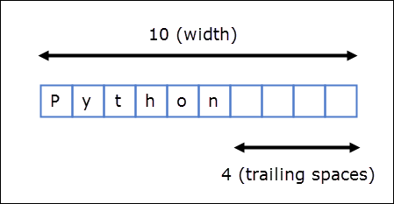

Unlike numbers, strings are left-justified by default. This means that when width is greater than the length of the value, the value is print left justified with trailing spaces instead of leading spaces.

If length of the string is greater than the width specified, then the width is automatically increased to match the length of the string.

|  |  |
| --- | --- |
| 1  2  3  4 | >>>  **>>> print**(format("Python", "4s"))  Python  >>> |

[Try it now](https://overiq.com/python-online-compiler/r0E/)

To right justify a string a string use > symbol as follows:

|  |  |
| --- | --- |
| 1  2  3  4  5 | >>>  **>>> print**(format("Python", ">10s"))  Python  >>>  >>> |

[Try it now](https://overiq.com/python-online-compiler/vgm/)

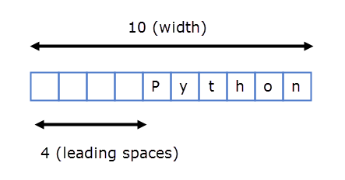

The statement print(format("Python", "<10s")) is same as print(format("Python", "10s")) because strings are printed left justified by default.